**Positive interactions and niche expansion in desert environments: A systematic review**

Diego A. Sotomayor1, Alessandro Filazzola2 & Christopher J. Lortie1,2, 3

1 Department of Geography, York University, 4700 Keele Street, Toronto, ON, M3J 1P3, Canada

2 Department of Biology, York University, 4700 Keele Street, Toronto, ON, M3J 1P3, Canada

3 The National Center for Ecological Analysis and Synthesis, UCSB. Santa Barbara, California, 93101.

* Corresponding Author: Diego A. Sotomayor, Department of Geography, York University. 4700 Keele Street, Lumbers Building room 218, Toronto, ON, M3J 1P3, Canada. E-mail: dsotomay@yorku.ca, phone number: +1 416 736 2100 ext. 40588.

**ABSTRACT**

Deserts are extreme stress environments with relatively high frequencies of positive plant interactions. Nurse plant species are facilitators that often increase the survival, biomass, and density of subdominant species. The niche is a powerful concept in ecology and at times not entirely coupled to positive interactions between species. Herein, we review the capacity for positive plant interactions to expand the niche of subdominant species by synthesizing the available literature with a formalized systematic review. We searched the Web of Science with terms such as niche, positive interactions, facilitation and deserts for ecological studies conducted in deserts. Primary studies were included that reported increases in the extent of niche due to positive plant interactions. Based on this analysis, we propose a heuristic model for the study of niche and positive interactions in arid ecosystems. This allowed us to identify five major hypotheses: (1) regeneration niche, niche segregation via (2) direct and (3) indirect effects, (4) evolutionary niche, and (5) spatiotemporal niche. We also found that positive interactions and niche have been reported across a wide range of plant species within deserts globally suggesting that positive interactions can be important for the niche of subdominant plant species in deserts.

**KEYWORDS:** Coexistence, niche, facilitation, regeneration niche, evolutionary niche, shrubs, spatiotemporal niche, niche segregation.

**INTRODUCTION**

Positive interactions have been shown to be more frequent in desert environments. From the individual to the community level, survival, biomass, fitness, and richness have all been shown to increase due to positive plant interactions (Callaway 2007, He et al. 2013, Soliveres et al. 2015). A dominant benefactor species (i.e. nurse plant) can modify the niche space of another species (i.e. the beneficiary) by ameliorating the microclimate and increasing the geographic extent the species can inhabit (Bruno et al. 2003). The influence of positive interactions on realized versus fundamental niche expansion is a matter of debate (Rodriguez-Cabal et al. 2012, Stachowicz 2012). It has been proposed that positive interactions increase the fundamental niche of beneficiary species (Rodriguez-Cabal 2012), but it has also been argued that this increase can also be due to a net increase in the geographic extent of realized niche space (i.e. that nurse plants provide more “realized niche” conditions, instead of changing the fundamental niche that remains constant) (Text box 1). However, to what extent do positive interactions increase the niche of subdominant species has rarely been examined, especially from a synthetic perspective integrating current empiric evidence. Such a synthesis would allow to determine the importance of positive interactions for niche expansion across arid environments as an eco-evolutionary process, but also to predict future distributions in light of large environmental changes as niche and positive interactions are inextricably related concepts.

The geographic extent of a species is also modified by the spatiotemporally fluctuating environmental conditions that characterize deserts (Noy-Meir 1973, Whitford 2002). Both realized niche and geographic extent are related concepts as they refer to the total area where a species is distributed (Bruno et al. 2003, Sandel 2015). But, they differ in that the former concept also includes interspecific interactions varying spatiotemporally that determine its area or geographic extent (Soberón 2007). Time and space are the main axes of variation for ecological processes, yet most studies study space even using space for time substitution as multi-year studies are more difficult to conduct. We propose that an integrated view of space and time including interspecific interactions within the concept of niche warrants a comprehensive examination of the dynamics of geographic distributions in environments characterized by significant environmental variation, such as deserts. The hypothesis tested here is that dominant plants in deserts expand the niche for a protégé species (Bruno et al. 2003, Rodriguez-Cabal et al. 2012) thereby resulting in an expansion of geographic ranges for these specific protégés. To broadly examine this hypothesis, we provide a formalized synthesis reviewing the key concepts associated with positive interactions and niche expansion. This novel synthesis showcases the mechanisms of niche relative to positive plant interactions and provides a better understanding of coexistence mechanisms in stressful environments. Arid ecosystems provide an ideal set of studies to examine the overlap in theory between niche and positive interactions because amelioration of stress is a common phenom and one that highly restricts species´ niches in combination with positive interactions (Soliveres et al. 2015, Ward 2016).

**METHODS**

To synthesize the breadth of concepts and approaches used to concurrently study niche and positive plant interactions in deserts, we conducted a formalized systematic review, i.e. a transparent review and included reproducible search terms and inclusion criteria (Lortie 2014) with a PRISMA report (Moher et al. 2009) (Figure 1). On June 2017 we conducted a search of the peer-reviewed literature using the Web of Science (database coverage 1990 to present) with the following terms: “niche“ AND (“plant facilitat*” OR “nurse plant” OR “positive interact*) AND (“arid” OR “desert”). After removing duplicates, there were a total of 70 publications. This set of studies was then processed with the following criteria: (1) empirical terrestrial plant studies from arid/semi-arid ecosystems; (2) interactions between dominant plants and understory species reported; and (3) explicit niche concepts tested. These criteria resulted in a total of 36 articles published between 1995 and 2017 (Table 1, Appendix 1). Each paper was analyzed in depth using spreadsheets to classify the niche concept as reported by the primary authors, application of the study (theoretical or applied), the methodology, interacting species (dominant plants and beneficiaries), country, and geographical location. Chi-square tests were used to determine differences between frequencies of examined concepts across ecosystem classes or different major niche concepts.

**RESULTS**

We assessed 36 peer-publications and found that the majority of studies on niche and positive interactions had a theoretical purpose (over 70% of studies) and examined coexistence and community assembly in both space and time (90% of theoretical studies). The concept of niche has not been extensively tested in the field globally (Figure 2). A total of 5 distinct niche concepts were tested across 12 different ecosystems in arid zones (Figure 3). We found no significant differences between the frequencies of concepts examined across ecosystem classes (Chi-squared = 20.8, p > 0.05) or different major niche concepts (Chi-squared = 7.1, p > 0.05), although there were a limited number of independent tests for these contrasts. The concept of positive interactions and niche was used to test five major purposes (Table 1), and field experiments were the most common (31%), followed by a combination of field surveys and big data (24%). Shrubs were the most common benefactor species tested in deserts (>70%). Niche concepts were applied to following topics: (1) species distribution modeling with conservation/restoration applications (7%); (2) prediction of climate change impacts on plant communities (14%); (3) niche characterization for reforestation and restoration purposes (7%); and (4) remote sensing (3%). Finally, most studies were conducted in non-tropical arid and semi-arid environments.

**DISCUSSION**

Dominant plants in deserts can expand the niche of subdominant species. Here, we show that niche considerations, positive interactions, in conjunction with geographic extent expansion are important issues relevant to the study of species distributions. The relationship of these concepts is of interest for ecological research, especially in light of current global change, as species distribution predictions need more realistic models that include all dimensions of the niche concept which is at the core of such models (Elith and Lethwick 2009, Guisan and Thuiller 2005). Here, we found that positive interactions expanded the niche of subdominant plants in a wide range of plant species and desert ecosystems worldwide, which sets the stage for further empiric studies examining how positive interactions predict the realized niche or the geographic extent of a species, and how these effects translate into ecological and evolutionary patterns. Although, this is a cursory study on the breadth of impacts that positive interactions can have on the niche, due to the limited number of peer-reviewed publications to date, this nonetheless allows for the design of studies that examine niche in both space and time, especially in deserts, where positive interactions are more frequent (He et al. 2013), and can represent a factor structuring entire communities (McIntire and Fajardo 2014).

This review allowed us to develop a spatiotemporal niche concept (Figure 4) as a heuristic model that allows for the inclusion of the both major axes of change in geographic extent - space and time, given that we found that they are rarely examined concurrently, yet their effect are simultaneous in the construction of that extent. This further allowed us to classify niche hypotheses into five categories: (1) regeneration niche, niche segregation via (2) direct and (3) indirect effects, (4) evolutionary niche, and (5) spatiotemporal niche. The model also allows for the concurrent investigation of both axes of change and provides a more comprehensive view of species distributions dynamics integrating spatiotemporal processes happening at different scales (e.g. ecological and evolutionary). The five hypotheses identified can be more closely related to one of the dimensions proposed, e.g. niche segregation occurs at small spatial scales and can be studied at that level, while the regeneration niche implies at least a few generations of a given species to be studied. Consequently, this model provides ecologists a tool for further research on how positive interactions impact the species’ niche in deserts.

An outcome of the systematic review was a clear capacity to classify desert facilitation studies by major niche concepts (Figure 4). The majority of studies reported on one niche concept while some reported combinations between the regeneration and spatiotemporal niche hypotheses (e.g. Valiente-Banuet et al. 2006, Weltzin and McPherson 2000). Niche segregation was also tested using direct and indirect effects concurrently (e.g. Gomez 2005, Soliveres et al. 2011), although this approach only accounted for relatively small proportion of the studies included. Most studies have characterized niche expansion in terms of its spatial dimension, i.e. how the geographic extent of a given species was increased due to positive interactions. For example, Chu et al. (2015) discussed the regeneration niche of three shrub species as a function of mapped abiotic and biotic conditions. Regeneration niches have also been characterized using field surveys (e.g. Nano and Clarke 2008, Gelviz-Gelvez et al. 2015) or with experiments manipulating both abiotic constraints (e.g. Weltzin et al. 2010, Butterfield and Briggs 2011, Carvajal et al. 2014) and biotic conditions such as competition and herbivory (Gomez 2005, Kambatuku et al. 2011). This exemplifies that the traditional conceptualization of niche is already in use within positive interactions research. Spatial segregation of species due to gradients such as water (e.g. Kulmatiski and Beard 2013, Martorell et al. 2015) and large environmental stress gradients (e.g. Eranen and Kozlov 2009, Soliveres et al. 2011) were also used to characterize niches across space, providing a more biogeographical perspective of niche expansion due to positive interactions. These characterizations of niche correspond with widely used conceptualizations on this topic by Hutchison (1957), Tilman (1994), or Chase and Leibold (2003). In summary, there is good conceptual consilience within this research subfield and limited evidence for semantic obfuscation.

Most niche concepts (Bruno et al. 2003, Rodriguez-Cabal et al. 2012, Stachowicz 2012) address the niche spatially. However, the niche can be expanded in time and through evolutionary processes as well (Chase and Leibold 2003, Erwin 2008, Kylafis and Loreau 2011). Evolutionary niche, regeneration niche, and spatiotemporal niche are niche concepts more associated with time relative to the other hypotheses reviewed. The evolutionary niche is likely the most dependent on time, but this key assumption is rarely examined to date. Nonetheless, Valiente-Banuet et al. (2006) used phylogenetic analyses in combination with field surveys to show that facilitation expanded phylogenetic diversity when quaternary arid-adapted lineages facilitated under their canopies tertiary lineages. Moreover, Valiente-Banuet et al. (2008) and Soliveres et al. (2012) found that dominant plants locally increase the phylogenetic diversity of understory plants. Other studies have integrated space and time as the niche of their target beneficiary species change with ontogeny (Miriti 2006), and it has also been shown that spatiotemporal environmental fluctuations promote tree-grass interaction mosaics (Nano and Clarke 2008, Cipriotti and Aguiar 2010). Time clearly represents an important empirically tested dimension of the niche, but we propose that further studies are needed on how dominant plants can promote niche evolution because of accelerated rates of change exacerbated by global change. In fact, the evolutionary niche (*sensu* Chase and Leibold 2003) has not been addressed in the context of positive interactions (but see Liancourt and Tielbörger 2011, Sotomayor et al. 2014), but the microenvironment present under the canopies of dominant plants is potentially a strong selective pressure (Kefi et al. 2008). Further research should explore the temporal consequences of niche expansion because these have important implications for coexistence in response to undergoing global changes and for evolution in response to temporally fluctuating environmental conditions.

Niche segregation via indirect effects was a novel research gap identified in this synthesis. The ideas are well developed in that by expanding the niche of beneficiary species under their canopies, dominant plants can increase the likelihood that these subordinate species interact with each another in these more concentrated microsites. Bulleri et al. (2016) identified similar patterns in that further studies are required to address this gap. Studies summarized here showed that canopies can alter the competitive balance between annuals and other life forms within their understories (e.g. Gomez 2005, Soliveres et al. 2011). Understanding the concurrent direct and indirect effects of canopies on the realized niches is thus likely very important because these microsites could be filtering species by their competitive characteristics (Lortie et al. 2004, Michalet et al. 2015). Furthermore, this has implications for coexistence in desert environments because niche partitioning can promote stable coexistence (Chesson 2000). The limited empirical research on this topic to date identified in this synthesis suggests that indirect interactions among beneficiary species relate to the niche and can advance both niche and competitive interactive theory.

Overall, this synthesis showed that positive interactions or plant facilitation in deserts can expand the niche of beneficiary species via five different mechanisms that we organized in a novel theoretical framework. Future research will benefit of a concurrent examination of space and time when assessing the importance of positive interactions for the determination of geographic extents.

**ACKNOWLEDGMENTS**

DAS and AF received funding from the Faculty of Graduate Studies at York University during the preparation of this review. CJL was funded by an NSERC Discovery Grant from the Government of Canada.

**REFERENCES**

Bertness, M. D. and Callaway, R. M. 1994. Positive interactions in communities. Trends in Ecology and Evolution 9: 187-191.

Brooker, R. W. 2005. Plant-plant interactions and environmental change. New Phytologist. 171: 271-284.

Brooker, R.W. et al. 2008. Facilitation in plant communities: the past, the present, and the future. Journal of Ecology 96:18-34.

Bruno, J.F. et al. 2003. Inclusion of facilitation into ecological theory. Trends in Ecology and Evolution 18:119-125.

Bulleri, F. et al. 2016. Facilitation and the niche: implications for coexistence, range shifts and ecosystem functioning. Functional Ecology 30: 70-78.

Butterfield, B. J. and Briggs, J. M. 2011. Regeneration niche differentiates functional strategies of desert woody plant species. Oecologia 165: 477-487.

Butterfield, B. J., et al. 2013. Alpine cushion plants inhibit the loss of phylogenetic diversity in severe environments. Ecology Letters 16: 478-486.

Callaway, R.M. 2007. Positive interactions and inter-dependence in plant communities. Springer, New York, USA.

Callaway, R. M. et al. 2002. Positive interactions among alpine plants increase with stress. Nature 417: 844-848.

Carvajal, D. E. et al. 2014. Growth and early seedling survival of four Atacama Desert shrub species under experimental light and water availability regimes. Revista Chilena de Historia Natural 87: 28.

Cavieres, L. A. and Badano, E. I. 2009. Do facilitative interactions increase species richness at the entire community level? Journal of Ecology 97: 1181-1191.

Chase, J.M. and Leibold M. A. 2003. Ecological Niches: Linking classical and contemporary app-roaches. The University of Chicago Press, Chicago and London.

Chesson, P. 2000. Mechanisms of maintenance of species diversity. Annual Reviews in Ecology and Systematics 31:343-366.

Chu, J. et al. 2015. Endemic shrubs in temperate arid and semiarid regions of northern China and their potentials for rangeland restoration. AoB Plants 7: plv063.

Cipriotti, P. A. et al. 2014. A complex network of interactions controls coexistence and relative abundances in Patagonian grass-shrub steppes. Journal of Ecology 102: 776-788.

Elith, J. and Leathwick, J. R. 2009. Species Distribution Models: Ecological Explanation and Prediction Across Space and Time. Annual Review in Ecology, Evolution and Systematics 40: 677–697.

Erwin, D. H. 2008. Macroevolution of ecosystem engineering, niche construction and diversity. Trends in Ecology and Evolution 23: 304-310.

Filazzola, A. and Lortie, C. J. 2014. A systematic review and conceptual framework for the mechanistic pathways of nurse plants. Global Ecology and Biogeography 23: 1335-1345.

Gomez, J. M. 2005. Long-term effects of ungulates on performance, abundance, and spatial distribution of two montane herbs. Ecological Monographs 75: 231-258.

Guisan, A. and Thuiller, W. 2005. Predicting species distribution: offering more than simple habitat models. Ecology Letters 8: 993-1009.

He, Q. and Bertness, M. D. 2014. Extreme stresses, niches and positive species interactions along stress gradients. Ecology 95: 1437-1443.

He, Q. et al. 2013. Global shifts towards positive species interactions with increasing environmental stress. Ecology Letters 16: 695-706.

Hutchinson, G. E. 1957. Concluding remarks. population studies: animal ecology and demography. – Cold Spring Harbor Symposia on Quantitative Biology 22:415–427.

Kéfi S., et al. 2008. Evolution of local facilitation in arid ecosystems. American Naturalist 172: E1–17.

Kulmatiski, A. and Beard, K. H. 2013. Woody plant encroachment facilitated by increased precipitation intensity. Nature Climate Change 3: 833-837.

Kylafis, G. and Loreau, M. 2011. Niche construction in the light of niche theory. Ecology Letters 14:82–90.

Liancourt, P. and Tielbörger, K. 2011. Ecotypic differentiation determines the outcome of positive interactions in a dryland annual plant species. Perspectives in Plant Ecology, Evolution and Systematics 13: 259-64.

Lortie, C. J. et al. 2004. Rethinking plant community theory. Oikos 107: 433-438.

Lortie, C. J. 2014. Formalized synthesis opportunities for ecology: systematic reviews and meta-analyses. Oikos 123: 897-902.

Lortie, C. J. et al. 2016. Functional assessment of animal interactions with shrub-facilitation complexes: a formal synthesis and conceptual framework. Functional Ecology 30: 41-51.

Martorell, C. et al. 2015. Co-existence in a species-rich grassland: competition, facilitation and niche structure over a soil depth gradient. Journal of Vegetation Science 26: 674-685.

McIntire, E. J. B. and Fajardo, A. 2014. Facilitation as a ubiquitous driver of diversity. New Phytologist 201: 403-416

Michalet, R., et al. 2006. Do biotic interactions shape both sides of the humped-back model of species richness in plant communities? Ecology Letters 9: 767-773.

Michalet, R. et al. 2015. Disentangling direct and indirect effects of a legume shrub on its understorey community. Oikos 124: 1251-1262.

Miriti, M. N. 2006. Ontogenetic shift from facilitation to competition in a desert shrub. Journal of Ecology 94: 973-979.

Moher D, Liberati A, Tetzlaff J, Altman DG, The PRISMA Group. 2009. Preferred Reporting Items for Systematic Reviews and Meta-Analyses: The PRISMA Statement. PLoS Med 6: e1000097.

Pescador, D. S. et al. 2014. Maintaining distances with the engineer: patterns of coexistence in plant communities beyond the patch‐bare dichotomy. New Phytologist. 204: 140-148.

Pulliam, H.R. 2000. On the relationship between niche and distribution. Ecology Letters 3:349–361.

Rodriguez-Cabal, M. A. et al. 2012. Positive interactions in ecology: filling the fundamental niche. Ideas in Ecology and Evolution 5:37-41.

Sandel, B. 2015. Towards a taxonomy of spatial scale-dependence. Ecography 38: 358-369.

Soberón, J. Grinnellian and Eltonian niches and geographic distributions of species. Ecology Letters 10: 1115-1123.

Soliveres, S. et al. 2011. Microhabitat amelioration and reduced competition among understorey plants as drivers of facilitation across environmental gradients: Towards a unifying framework. Perspectives in Plant Ecology, Evolution and Systematics 13: 247-258.

Soliveres, S. et al. 2012. Environmental conditions and biotic interactions acting together promote phylogenetic randomness in semi-arid plant communities: new methods help to avoid misleading conclusions. Journal of Vegetation Science 23: 822-836.

Soliveres, S. et al. 2015. Moving forward on facilitation research: response to changing environments and effects on the diversity, functioning, and evolution of plant communities. Biological Reviews 90: 297-313.

Sotomayor D. A. and Lortie, C. J. 2015. Indirect interactions in terrestrial plant communities: emerging patterns and research gaps. Ecosphere 6: art 103.

Sotomayor, D. A. et al. 2014. Nurse-plant effects on the seed biology and germination of desert annuals. Austral Ecology 39: 786-794.

Tilman, D. 1994. Competition and biodiversity in spatially structured habitats. Ecology 75: 2-16.

Valiente-Banuet, A. et al. 2006. Modern quaternary plant lineages promote diversity through facilitation of ancient tertiary lineages. Proceedings of National Academy of Sciences USA 103: 16812-16817.

Valiente-Banuet, A. and Verdu, M. 2008. Temporal shifts from facilitation to competition occur between closely related taxa. Journal of Ecology 96: 489-494.

Verdu, M. et al. 2010. The phylogenetic structure of plant facilitation networks changes with competition. Journal of Ecology 98: 1454-1461.

**Text box 1.** The dominant niche-facilitation concepts defined for this systematic review. The key reference(s) provide clear definitions to each term listed.

|  |  |  |
| --- | --- | --- |
| Term | Standard definition | Key reference(s) |
| Niche | The set of environmental conditions where a species can live indefinitely in the absence of negative interspecific interactions. The concept has been amended to include the influence of positive interactions when considering the realized niche. | Bruno et al. 2003 |
| Geographic extent | The geographic area where a species is present. | Bruno et al. 2003, Sandel 2015 |
| Facilitation | A biotic interaction when the effect of one species on another is positive, i.e. that one species performs better than its average conditions due to the effects of the other. | Bruno et al. 2003 |
| Nurse plant | A plant species that usually harbors a great diversity of other organisms under their cover or canopy. | Filazzola and Lortie 2014 |
| Niche expansion | A process by which the niche of a species is augmented by the effects of another species, resulting in an increase in the geographic extent of the species. | Rodriguez-Cabal et al. 2012, Stachowicz 2012 |

**Table 1.** Main concepts associated with niche expansion by dominant plants in arid and semi-arid systems. Percentages refer to the proportion of studies that discussed each topic from a keyword search in Web of Science on June 2017.

|  |  |  |  |
| --- | --- | --- | --- |
| Concept | (%) | Description | Main references |
| Evolutionary niche | 11.1 | Dominant plants increase phylogenetic diversity of understory communities | Soliveres et al. 2012, Verdu et al. 2010 |
| Niche segregation via indirect effects | 5.5 | Dominant plants promote niche segregation via indirect effects in their canopies: increased competition or herbivore defense/associational resistance | Soliveres et al. 2011, Gomez 2005 |
| Niche segregation via direct effects | 25.1 | Dominant plants promote niche segregation via direct effects in space and time. Includes interactions at different depth (hydrological niche). | Martorell et al. 2015, Kulmatiski & Beard 2013 |
| Regeneration niche | 38.9 | Dominant plants provide proper abiotic or biotic canopy conditions for the recruitment of other plants. Includes niche characterization. | Chu et al. 2015, Butterfield & Briggs 2011, Valiente-Banuet et al. 2006 |
| Spatiotemporal niche | 19.4 | Dominant plants provide niches that change across time and space. Examples include ontogenic changes and yearly fluctuations | Cipriotti et al. 2014, Miriti 2006 |

**Figures**

**Fig. 1.** PRISMA flow diagram (Moher et al., 2009) depicting the search protocol and workflow in determining the studies used in the systematic review.

**Fig. 2.** Map of evidence on niche concepts and positive interactions across the desert environments found in the systematic review.

**Fig. 3.** Distribution of niche concepts tested across arid environments reported in the systematic review.

**Fig. 4.** A heuristic model for the spatial and temporal dimensions of niche expansion by dominant plants in desert systems. The realized niche (grey rectangle) expands toward and beyond the fundamental niche (black line) in both axes according to the respective niche concept discussed in the literature. Bi-directional vectors indicate a combination of both biotic and abiotic factors that constrain niches. Each concept is located in relation to the main axis in which it has been found to vary.

Studies included in quantitative synthesis (meta-analysis)  
(n = 36 )

Studies included in qualitative synthesis  
(n = 0 )

Full-text articles excluded, with reasons  
(n = 0 )

Full-text articles assessed for eligibility  
(n = 36 )

Records excluded  
(n = 34 )

Records screened  
(n = 70 )

Records after duplicates removed  
(n = 70 )

Additional records identified through other sources  
(n = 0 )

## Identification

## Eligibility

## Included

## Screening

Records identified through database searching  
(n = 186 )

**Fig. 2**

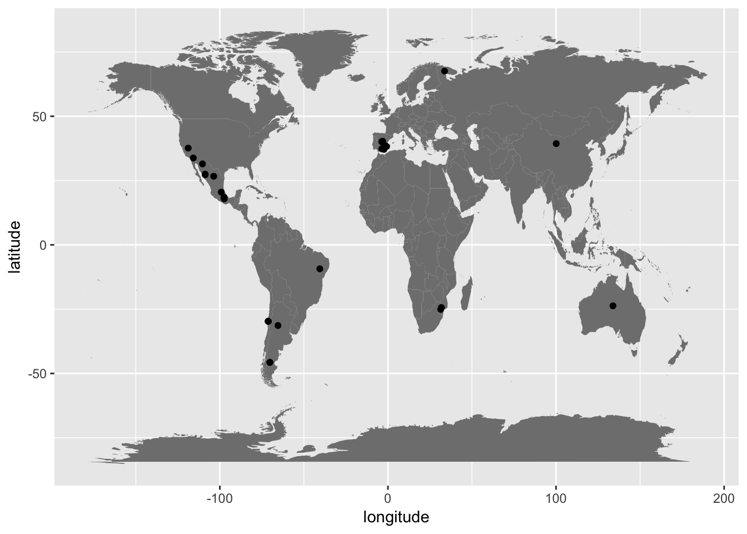

**Fig. 3**

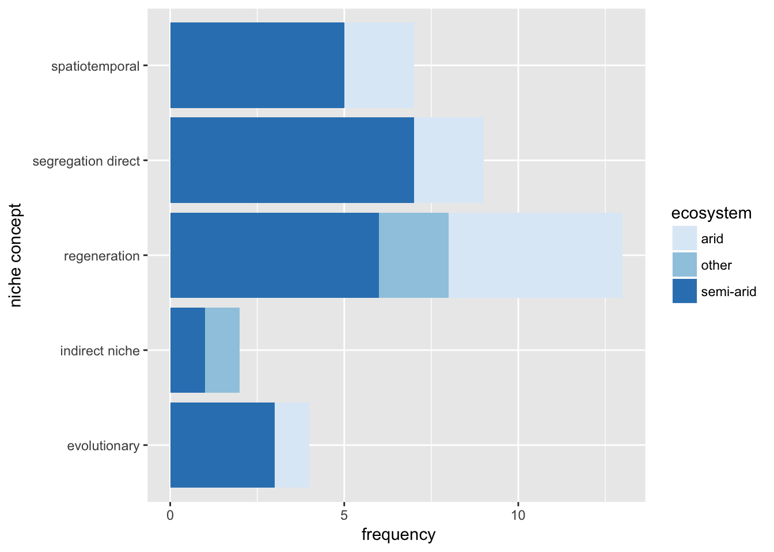

**Fig. 4**



**Appendix 1.** References included in this systematic review.

Alvarez-Yepiz JC, Burquez A, Dovciak M. 2014. Ontogenetic shifts in plant-plant interactions in a rare cycad within angiosperm communities. Oecologia 175: 725-735.

Alvarez-Yepiz JC, Cueva A, Dovciak M, Teece M, Yepez EA. 2014. Ontogenetic resource-use strategies in a rare long-lived cycad along environmental gradients. Conservation Physiology 2: doi:10.1093/conphys/cou034.

Butterfield BJ, Briggs JM. 2011. Regeneration niche differentiates functional strategies of desert woody plant species. Oecologia 165: 477-487.

Carvajal DE, Loayza AP, Lopez RP, Toro PJ, Squeo FA. 2014. Growth and early seedling survival of four Atacama Desert shrub species under experimental light and water availability regimes. Revista Chilena de Historia Natural 87: art 28.

Chacon-Labella J, de la Cruz M, Escudero A. 2016. Beyond the classical nurse species effect: diversity assembly in a Mediterranean semi-arid dwarf shrubland. Journal of Vegetation Science 27: 80-88.

Chu J, Yang H, Lu Q, Zhang X. 2015. Endemic shrubs in temperate arid and semiarid regions of northern China and their potentials for rangeland restoration. AoB Plants 7: plv063.

Cipriotti PA, Aguiar MR. 2010. Resource partitioning and interactions enable coexistence in a grass-shrub steppe. Journal of Arid Environments 74: 1111-1120.

Cipriotti PA, Aguiar MR, Wiegand T, Paruelo JM. 2014. A complex network of interactions controls coexistence and relative abundances in Patagonian grass-shrub steppes. Journal of Ecology 102: 776-788.

Eranen JK, Kozlov MV. 2009. Interactions between mountain birch seedlings from differentiated populations in contrasting environments of subarctic Russia. Plant Ecology 200: 167-177.

Gelviz-Gelvez SM, Pavon NP, Illoldi-Rangel P, Ballesteros-Barrera C. 2015. Ecological niche modeling under climate change to select shrubs for ecological restoration in Central Mexico. Ecological Engineering74: 302-309.

Gillespie IG, Loik ME. 2004. Pulse events in Great Basin Desert shrublands: physiological responses of *Artemisia tridentata* and *Purshia tridentata* seedlings to increased summer precipitation. Journal of Arid Environments 59: 41-57.

Gomez JM. 2005. Long-term effects of ungulates on performance, abundance, and spatial distribution of two montane herbs. Ecological Monographs 75: 231-258.

Gross N, Boerger L, Soriano-Morales SI, Le Bagousse-Pinguet Y, Quero JL, Garcia-Gomez M, Valencia-Gomez E, Maestre FT. 2013. Uncovering multiscale effects of aridity and biotic interactions on the functional structure of Mediterranean shrublands. Journal of Ecology 101: 637-649.

Haase P, Pugnaire FI, Clark SC, Incoll LD. 1996. Spatial patterns in a two-tiered semi-arid shrubland in southeastern Spain. Journal of Vegetation Science 7: 527-534.

Higgins SI, Delgado-Cartay MD, February EC, Combrink HJ. 2011. Is there a temporal niche separation in the leaf phenology of savanna trees and grasses? Journal of Biogeography 38: 2165-2175.

Kambatuku JR, Cramer MD, Ward D. 2011. Savanna tree-grass competition is modified by substrate type and herbivory. Journal of Vegetation Science 22: 225-237.

Kulmatiski A, Beard KH. 2013. Woody plant encroachment facilitated by increased precipitation intensity. Nature Climate Change 3: 833-837.

Lopez RP, Squeo FA, Gutierrez JR. 2016. Differential effect of shade, water and soil type on emergence and early survival of three dominant species of the Atacama Desert. Austral Ecology 41: 428-436.

Luzuriaga AL, Sanchez AM, Maestre FT, Escudero A. 2012. Assemblage of a Semi-Arid Annual Plant Community: Abiotic and Biotic Filters Act Hierarchically. PlOS One 7: e41270.

Martinez-Tilleria K, Loayza AP, Sandquist DR, Squeo FA. 2012. No evidence of a trade-off between drought and shade tolerance in seedlings of six coastal desert shrub species in north-central Chile. Journal of Vegetation Science 23: 1051-1061.

Martorell C, Almanza-Celis CAI, Perez-Garcia EA, Sanchez-Ken JG. 2015. Co-existence in a species-rich grassland: competition, facilitation and niche structure over a soil depth gradient. Journal of Vegetation Science 26: 674-685.

Miriti MN. 2006. Ontogenetic shift from facilitation to competition in a desert shrub. Journal of Ecology 94: 973-979.

Montana C, Cavagnaro B, Briones O. 1995. Soil-water use by coexisting shrubs and grasses in the southern Chihuahuan desert, Mexico. Journal of Arid Environments 31: 1-13.

Nano CEM, Clarke PJ. 2008. Variegated desert vegetation: Covariation of edaphic and fire variables provides a framework for understanding mulga-spinifex coexistence. Austral Ecology 33: 848-862.

Navarro-Cano JA, Goberna M, Valiente-Banuet A, Verdu M. 2016. Same nurse but different time: temporal divergence in the facilitation of plant lineages with contrasted functional syndromes. Functional Ecology 30: 1854-1861.

Paez SA, Marco DE. 2000. Seedling habitat structure in dry Chaco forest (Argentina). Journal of Arid Environments 46: 57-68.

Paterno GB, Siqueira F, Jose A, Ganade G. 2016. Species-specific facilitation, ontogenetic shifts and consequences for plant community succession. Journal of Vegetation Science 27: 606-615.

Rey PJ, Alcantara JM, Manzaneda AJ, Sanchez-Lafuente AM. 2016. Facilitation contributes to Mediterranean woody plant diversity but does not shape the diversity-productivity relationship along aridity gradients. New Phytologist 211: 464-476.

Soliveres S, DeSoto L, Maestre FT, Olano JM. 2010. Spatio-temporal heterogeneity in abiotic factors modulate multiple ontogenetic shifts between competition and facilitation. Perspectives in Plant Ecology, Evolution and Systematics12: 227-234.

Soliveres S, Eldridge DJ, Maestre FT, Bowker MA, Tighe M, Escudero A. 2011. Microhabitat amelioration and reduced competition among understorey plants as drivers of facilitation across environmental gradients: Towards a unifying framework. Perspectives in Plant Ecology, Evolution and Systematics. 13: 247-258.

Soliveres S, Torices R, Maestre FT. 2012. Environmental conditions and biotic interactions acting together promote phylogenetic randomness in semi-arid plant communities: new methods help to avoid misleading conclusions. Journal of Vegetation Science 23: 822-836.

Valiente-Banuet A, Rumebe AV, Verdu M, Callaway RM. 2006. Modern quaternary plant lineages promote diversity through facilitation of ancient tertiary lineages. Proceedings of the National Academy of Sciences of the United States of America 103: 16812-6817.

Valiente-Banuet A, Verdu M. 2008. Temporal shifts from facilitation to competition occur between closely related taxa. Journal of Ecology 96: 489-494.

Verdu M, Jordano P, Valiente-Banuet A. 2010. The phylogenetic structure of plant facilitation networks changes with competition. Journal of Ecology 98: 1454-1461.

Weltzin JF, McPherson GR. 2000. Implications of precipitation redistribution for shifts in temperate savanna ecotones. Ecology 81: 1902-1913.

Zhang G, Yang Q, Wang X, Zhao W. 2015. Size-related change in *Nitraria* *sphaerocarpa* patches shifts the shrub-annual interaction in an arid desert, northwestern China. Acta Oecologica-International Journal of Ecology 69: 121-128.

**Appendix 2.** PRISMA checklist for this systematic review following Moher et al. (2009).

|  |  |  |  |
| --- | --- | --- | --- |
| **Section/topic** | **#** | **Checklist item** | **Reported on page #** |
| **TITLE** | | |  |
| Title | 1 | Identify the report as a systematic review, meta-analysis, or both. | 1 |
| **ABSTRACT** | | |  |
| Structured summary | 2 | Provide a structured summary including, as applicable: background; objectives; data sources; study eligibility criteria, participants, and interventions; study appraisal and synthesis methods; results; limitations; conclusions and implications of key findings; systematic review registration number. | 2 |
| **INTRODUCTION** | | |  |
| Rationale | 3 | Describe the rationale for the review in the context of what is already known. | 3-4 |
| Objectives | 4 | Provide an explicit statement of questions being addressed with reference to participants, interventions, comparisons, outcomes, and study design (PICOS). | 4 |
| **METHODS** | | |  |
| Protocol and registration | 5 | Indicate if a review protocol exists, if and where it can be accessed (e.g., Web address), and, if available, provide registration information including registration number. | 5 |
| Eligibility criteria | 6 | Specify study characteristics (e.g., PICOS, length of follow-up) and report characteristics (e.g., years considered, language, publication status) used as criteria for eligibility, giving rationale. | 5 |
| Information sources | 7 | Describe all information sources (e.g., databases with dates of coverage, contact with study authors to identify additional studies) in the search and date last searched. | 5 |
| Search | 8 | Present full electronic search strategy for at least one database, including any limits used, such that it could be repeated. | 5 |
| Study selection | 9 | State the process for selecting studies (i.e., screening, eligibility, included in systematic review, and, if applicable, included in the meta-analysis). | 5 |
| Data collection process | 10 | Describe method of data extraction from reports (e.g., piloted forms, independently, in duplicate) and any processes for obtaining and confirming data from investigators. | 5 |
| Data items | 11 | List and define all variables for which data were sought (e.g., PICOS, funding sources) and any assumptions and simplifications made. | 5 |
| Risk of bias in individual studies | 12 | Describe methods used for assessing risk of bias of individual studies (including specification of whether this was done at the study or outcome level), and how this information is to be used in any data synthesis. | NA |
| Summary measures | 13 | State the principal summary measures (e.g., risk ratio, difference in means). | 5 |
| Synthesis of results | 14 | Describe the methods of handling data and combining results of studies, if done, including measures of consistency (e.g., I2) for each meta-analysis. | 5 |
| Risk of bias across studies | 15 | Specify any assessment of risk of bias that may affect the cumulative evidence (e.g., publication bias, selective reporting within studies). | NA |
| Additional analyses | 16 | Describe methods of additional analyses (e.g., sensitivity or subgroup analyses, meta-regression), if done, indicating which were pre-specified. | 5 |
| **RESULTS** | | |  |
| Study selection | 17 | Give numbers of studies screened, assessed for eligibility, and included in the review, with reasons for exclusions at each stage, ideally with a flow diagram. | 5 |
| Study characteristics | 18 | For each study, present characteristics for which data were extracted (e.g., study size, PICOS, follow-up period) and provide the citations. | 6, Appnd. 1 |
| Risk of bias within studies | 19 | Present data on risk of bias of each study and, if available, any outcome level assessment (see item 12). | NA |
| Results of individual studies | 20 | For all outcomes considered (benefits or harms), present, for each study: (a) simple summary data for each intervention group (b) effect estimates and confidence intervals, ideally with a forest plot. | NA |
| Synthesis of results | 21 | Present the main results of the review. If meta-analyses are done, include for each, confidence intervals and measures of consistency | 5-6 |
| Risk of bias across studies | 22 | Present results of any assessment of risk of bias across studies (see Item 15). | NA |
| Additional analysis | 23 | Give results of additional analyses, if done (e.g., sensitivity or subgroup analyses, meta-regression [see Item 16]). | 6 |
| **DISCUSSION** | | |  |
| Summary of evidence | 24 | Summarize the main findings including the strength of evidence for each main outcome; consider their relevance to key groups (e.g., healthcare providers, users, and policy makers). | 6-7 |
| Limitations | 25 | Discuss limitations at study and outcome level (e.g., risk of bias), and at review-level (e.g., incomplete retrieval of identified research, reporting bias). | 7 |
| Conclusions | 26 | Provide a general interpretation of the results in the context of other evidence, and implications for future research. | 6-11 |
| **FUNDING** | | |  |
| Funding | 27 | Describe sources of funding for the systematic review and other support (e.g., supply of data); role of funders for the systematic review. | 11 |